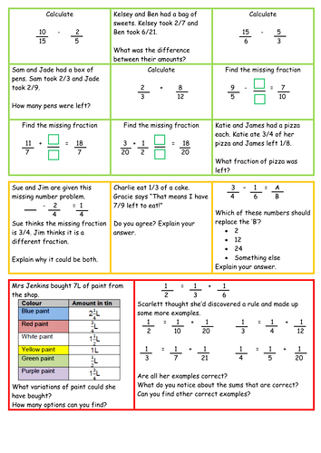
FRACTIONS PROBLEMS

