￼ttps://images-na.ssl-images-qa
Nursery Activities and Play

It has been a very busy half term for us and the children have enjoyed taking part in lots of different activities. This week we have especially enjoyed thinking about the people we love and taking part in Valentines’ day themed craft activities.

Ongar Place Primary School, Addlestone, Surrey, 01932 842785

13th February 2026

Ongar Place
Nursery News

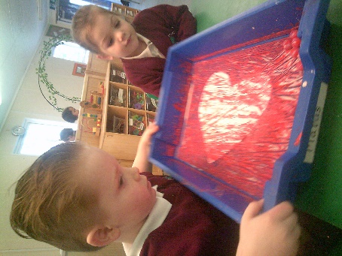
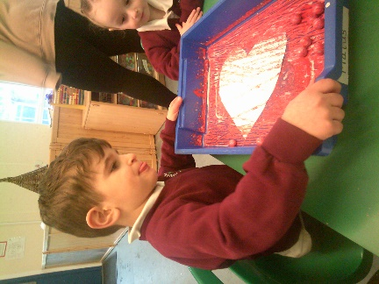
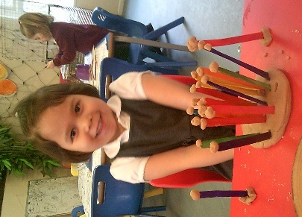
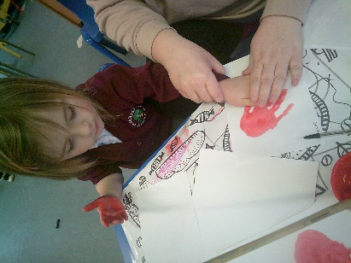
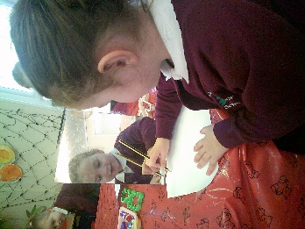
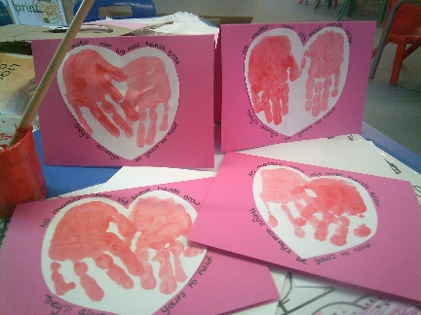
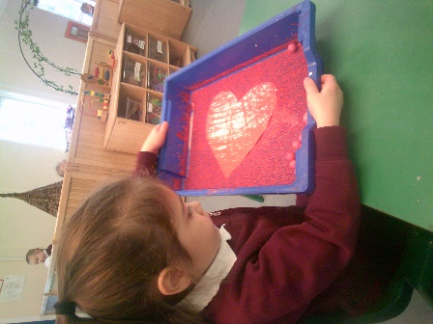
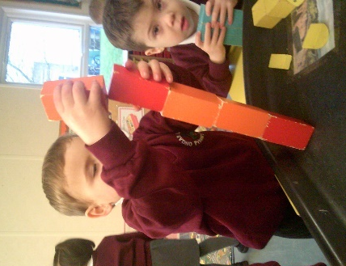
Information for Families
It was lovely to meet with you for parent meetings this week. We hope you found the meetings useful.

Some upcoming dates for your diary:

Friday 27th February
Break the Rules Day

Tuesday 3rd and Thursday 5th March
Family Learning Sessions

Week commencing Monday 2nd March
Book fair in school

Next half term’s learning

Next half term, our topic will be ‘Plants and Gardens’. We will be reading stories about growing things, exploring the school grounds and planting our own seeds to watch them grow.
If you have any spare bulbs, flower seeds or soil that you don’t need at home, we would be grateful for any donations
Thank you for your ongoing support this term. Have a wonderful half term break and we look forward to seeing you back on Monday 23rd February.

